Loc Size Chart
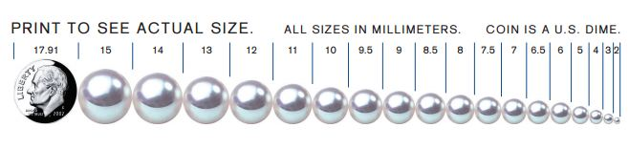

Congo= 15 mm
Large= 12 mm
Medium= 8 mm
Small= 6 mm
Micro= 4mm

